Memo for generating PNF, PNNF, SNF, NNF 1M8 two parameter bifurcation

Current version shown below.

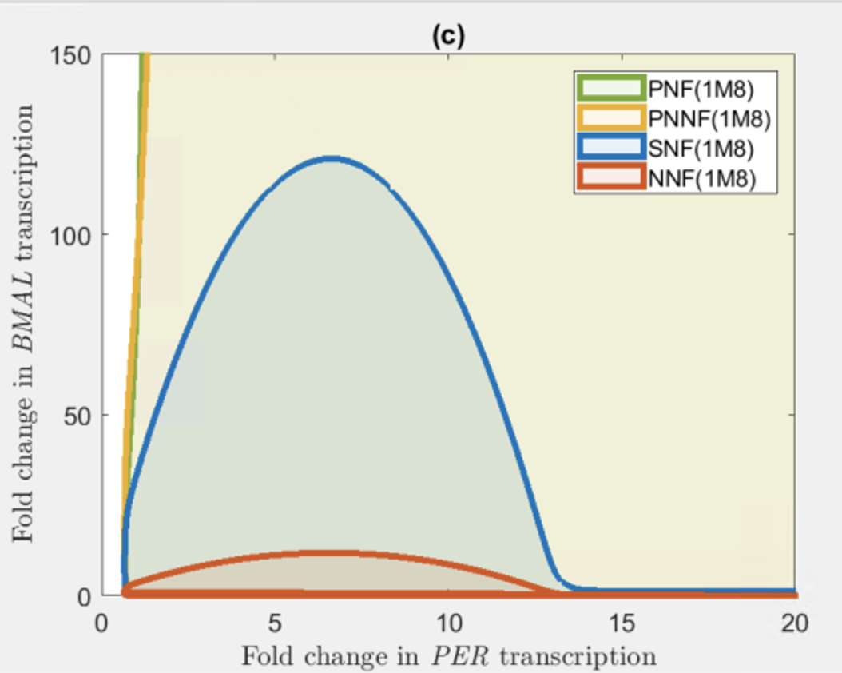

Test 1. NNF 1M8 model with different Vmax value

|  |  |
| --- | --- |
| Case id | Vmax |
| 1 | 0.1 |
| 2 | 1 |

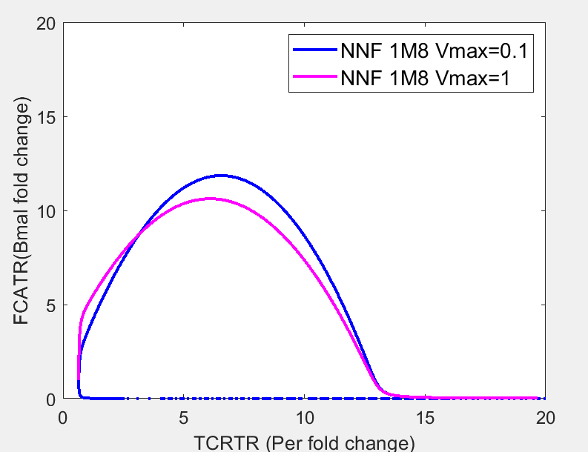

Test 2. Upper bound of PNF model

|  |  |  |  |
| --- | --- | --- | --- |
| Test id | Initial FCRTR | Initial FCATR | Oscillatory |
| 1 | 5 | 1,000 | True |
| 2 | 5 | 10,000 | True |
| 3 | 5 | 100,000 | True |
| 4 | 5 | 1000,000 | True |

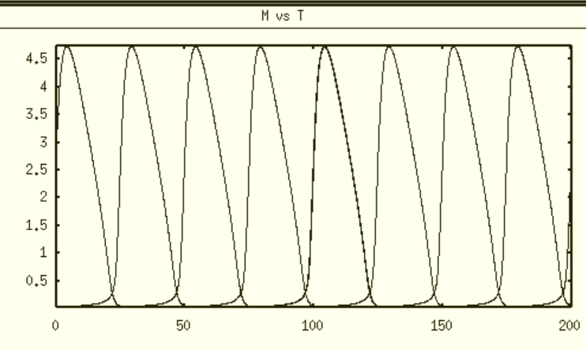 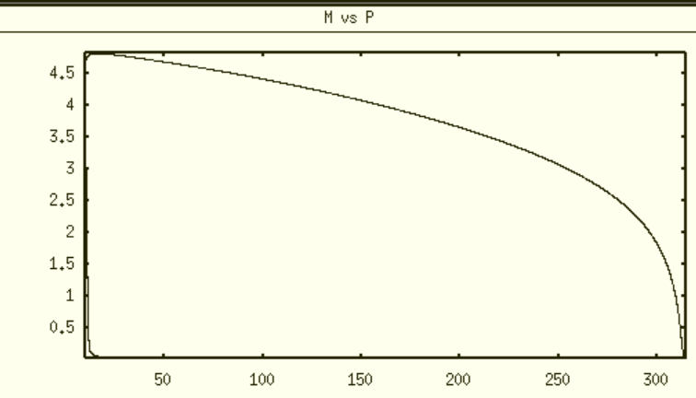

Case 1 Time course trajectory, phase diagram

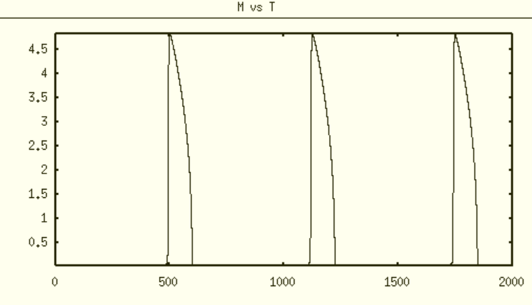 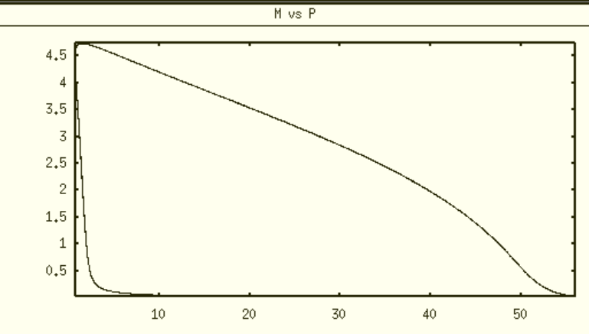

Case 2 Time course trajectory, phase diagram

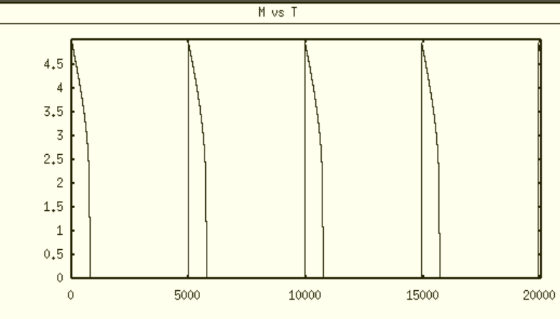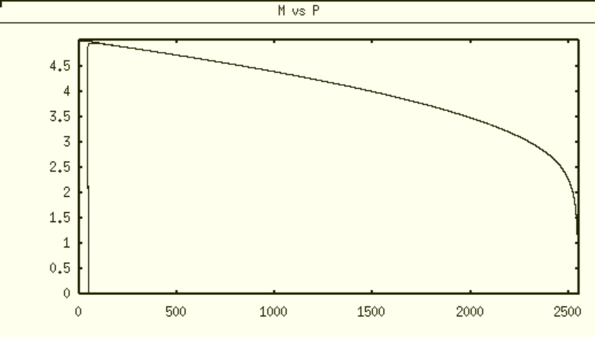

Case 3 Time course trajectory, phase diagram

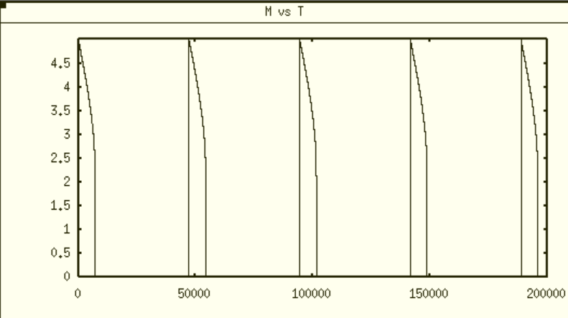 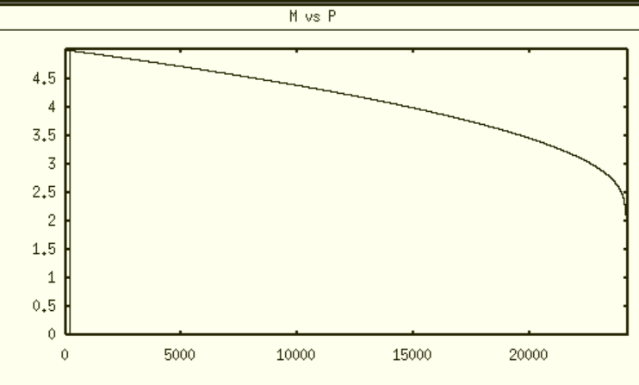

Case 4 Time course trajectory, phase diagram

Test3: Upper bound of PNNF model Vmax = 1

|  |  |  |  |
| --- | --- | --- | --- |
| Test id | Initial FCRTR | Initial FCATR | Oscillatory |
| 1 | 5 | 1,000 | True |
| 2 | 5 | 10,000 | True |
| 3 | 5 | 100,000 | True |
| 4 | 5 | 1000,000 | True |

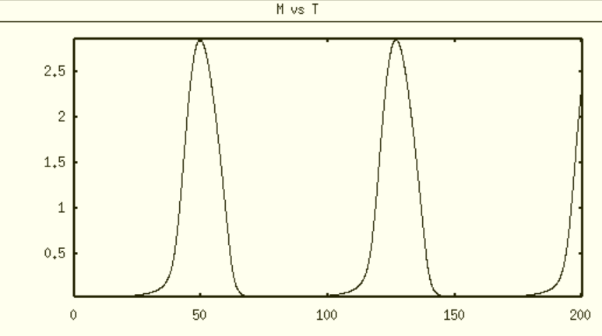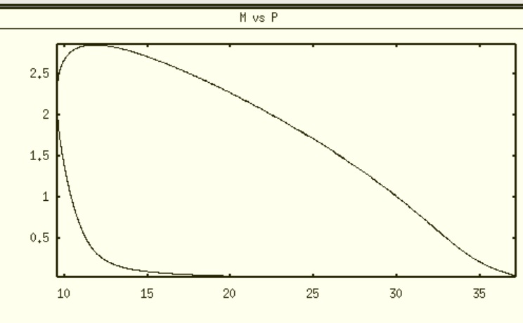

case 1 Time course trajectory, phase diagram

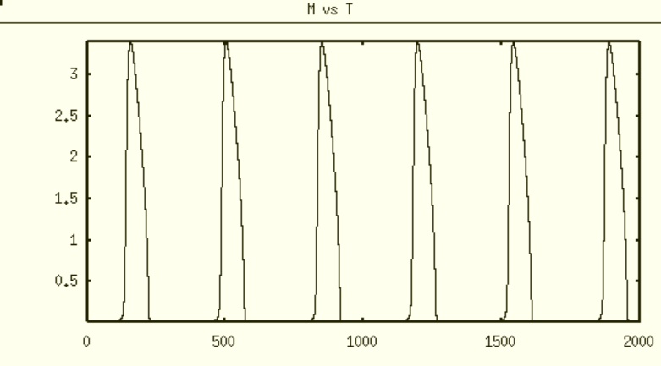 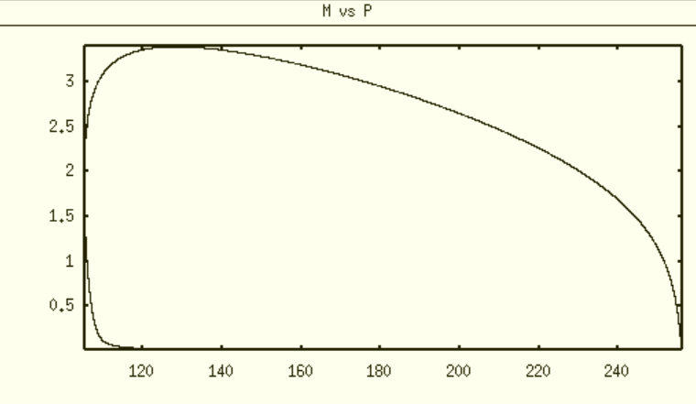

case 2 Time course trajectory, phase diagram

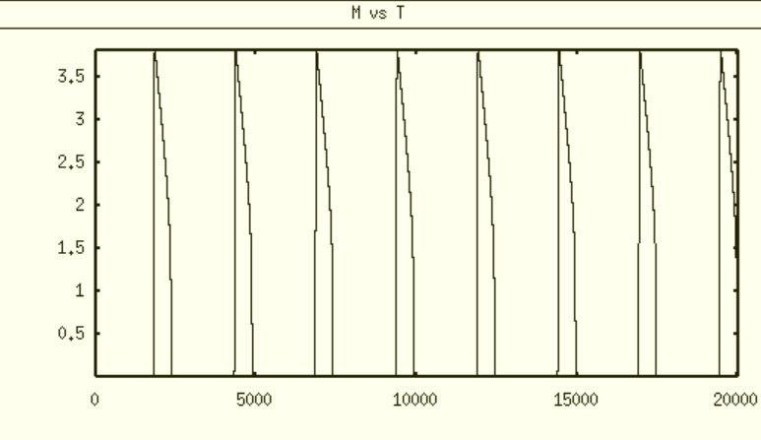 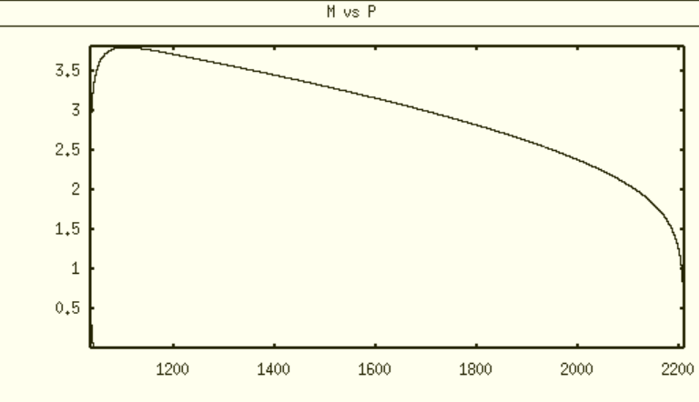

case3 Time course trajectory, phase diagram

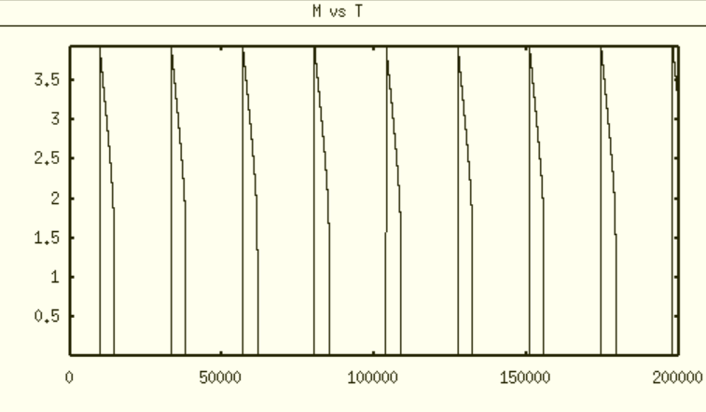 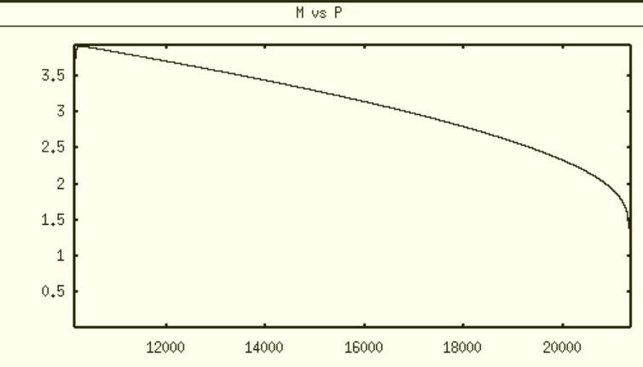

case4 Time course trajectory, phase diagram

Issue 2: right bound and subcritical Hopf bifurcation point

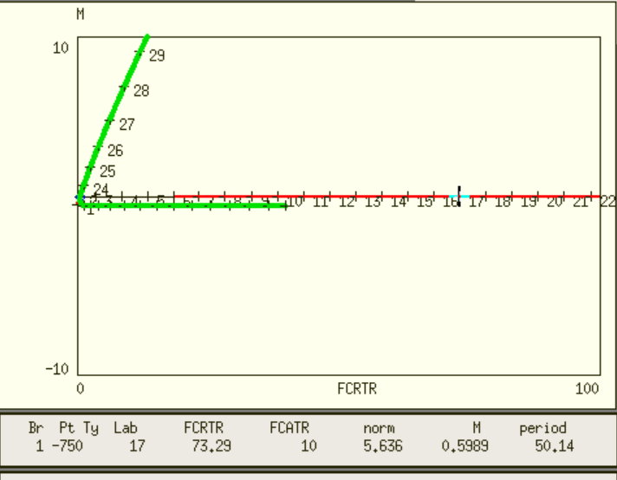

FCRTR =0.1, FCATR=10

How to catch the subcritical Hopf bifurcation point